**REPORT** IS 456 2000

GUI Requirements

This is the ration which keeps all other things equivalent to 1 or whatever we have given the value.

Option: Design Option:

Set all Target Ratio for design default to **1**

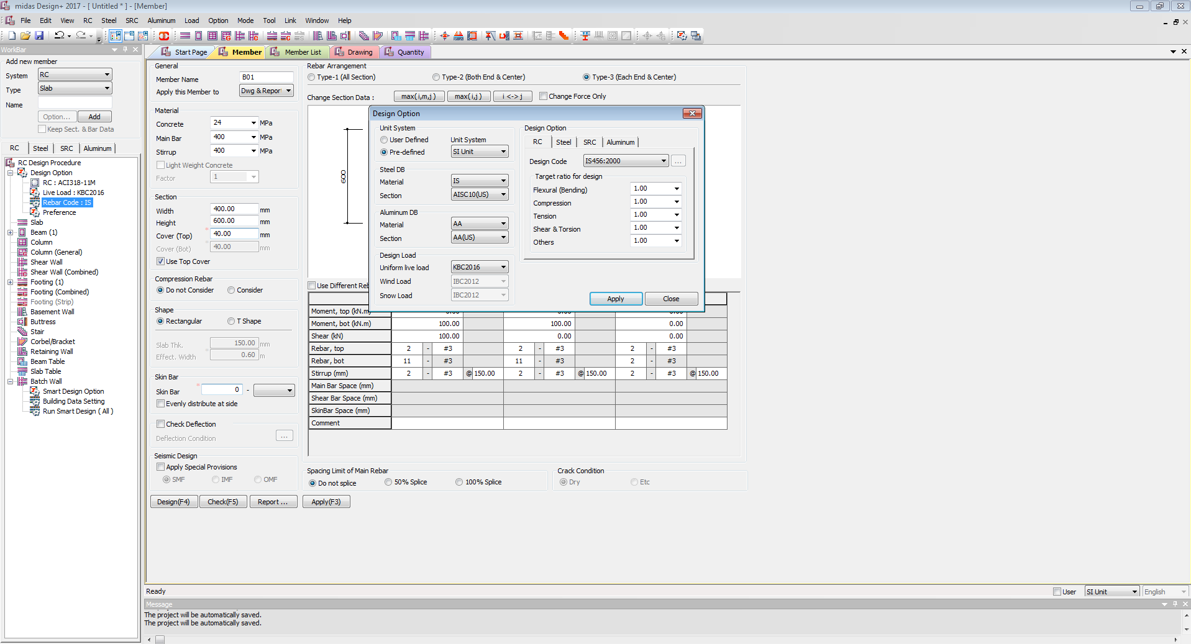

**Option**

**Design Option**

**RC**

Design code: **IS 456 2000**

Target ratio for Design

All to **1**

Section Data Base

Material **IS**

Default View

KBC2016

IS456 2000

Beam Option Glow

IS

NEWBUTTON

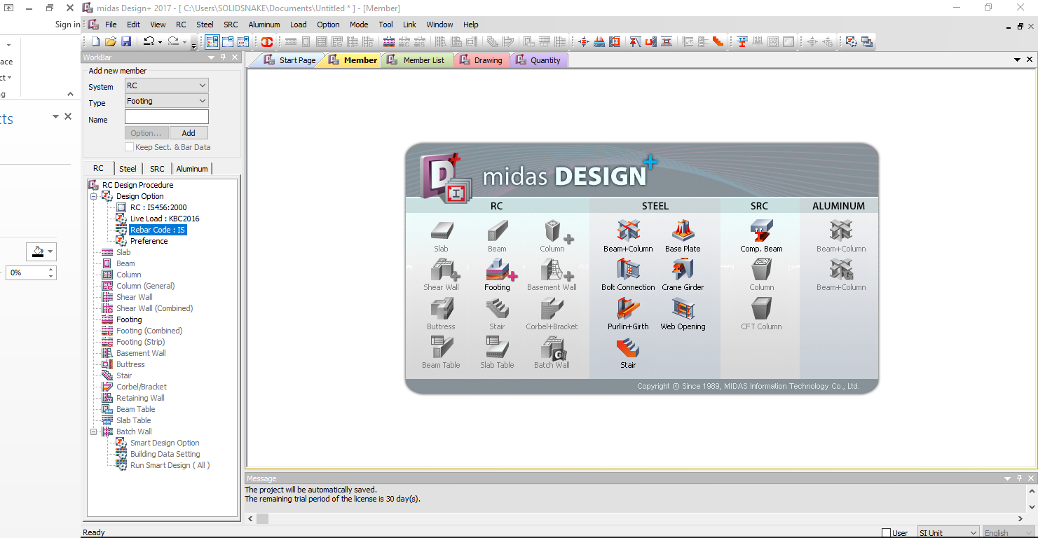

Default setup: On Click New Button

On Click New Button set Default as:

RC: **IS456 2000**

Live Load: **KBC2016**

Rebar Code: **IS**

Preferences: General

Set Default Preferences as per Listed to IS 456 2000

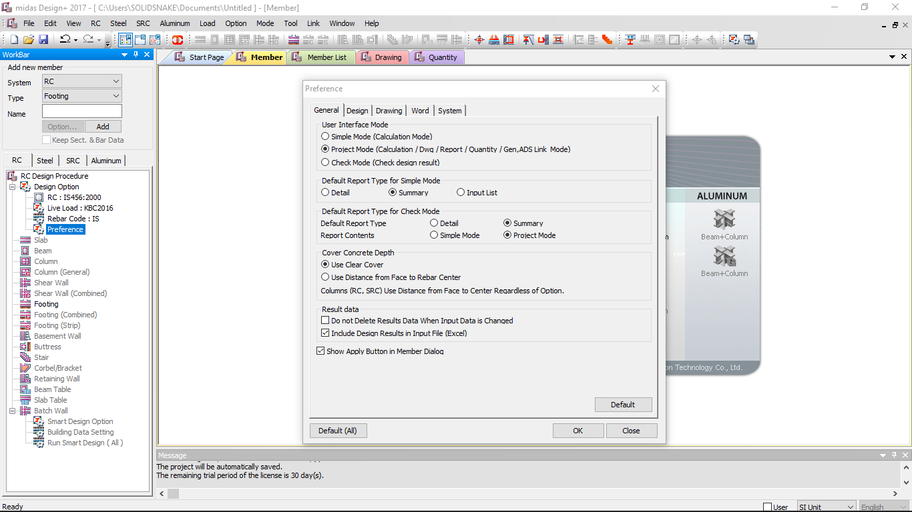

Default setup: In Preferences

**General**

User Interface Mode: **Project Mode**

Default Report type for simple Mode: **Summary**

Default Report type for check Mode

Default Report Type: **Summary**

Report Contents: **Project Mode**

Cover concrete Depth: **Use Clear Cover or Use Distance from Face to center**

Result Data

* + - **NO** do not delete Results Data
    - **YES** Include Design Results in File
    - **YES** show apply Button in Member Dialog

Preferences: Design

Increment to 50mm

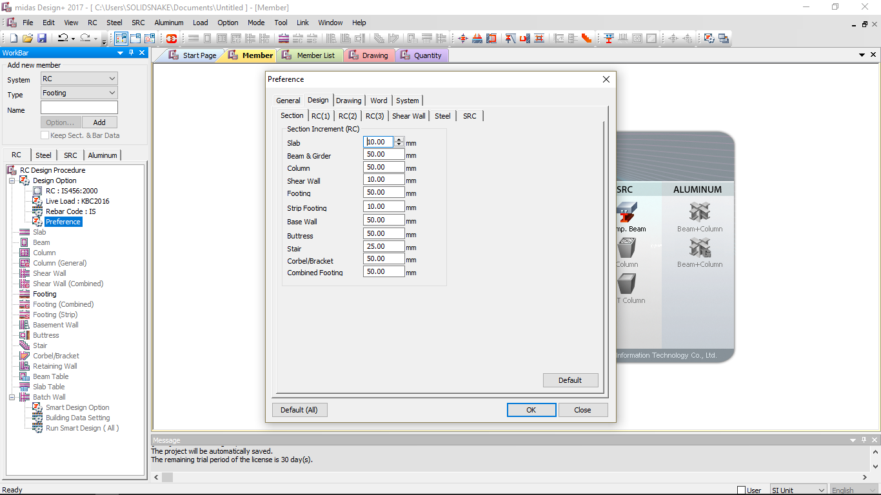







Default setup: In Preferences

**Design**

**Section**

Beam and Girder Increment to **50 mm**

Preferences: Design

Set Default Preferences as per Listed to IS 456 2000

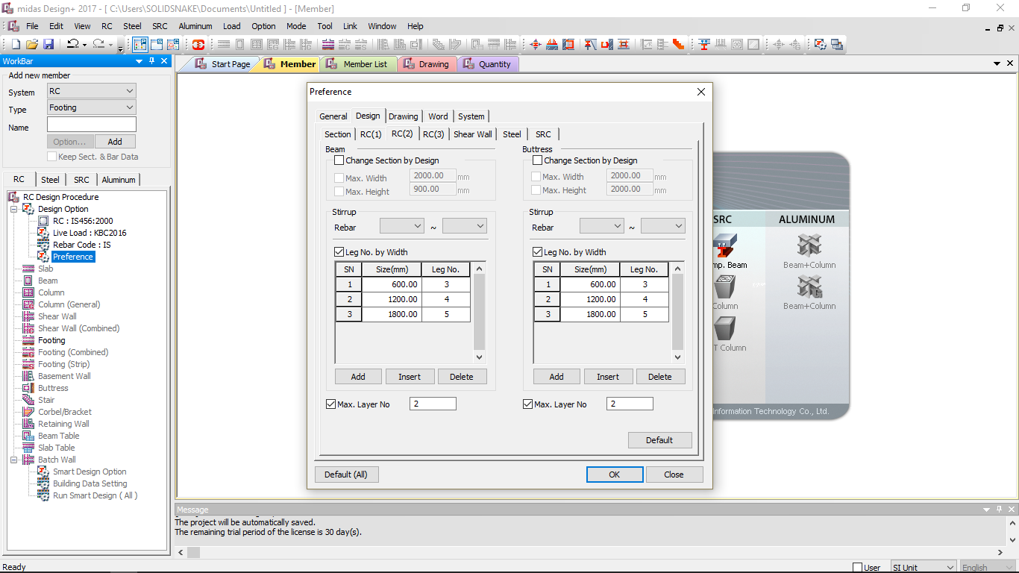





Default setup: In Preferences

**Design**

**RC(2)**

Beam

Check **No** Change Section by Design (If we push design it may change section design)

Check **Yes** Max Width **2000 mm**

Check **Yes** Max Height **2000 mm**

Stirrup

Rebar **6mm – 25mm**

Check **Yes** Leg number by Width

Size **250**  Leg No **2**

Size **600**  Leg No **3**

Size **1200** Leg No **4**

Size **1800** Leg No **5**

Check **Yes** Max Layer No **2**

Preferences: Drawing

Set Default Preferences as per Listed to IS 456 2000

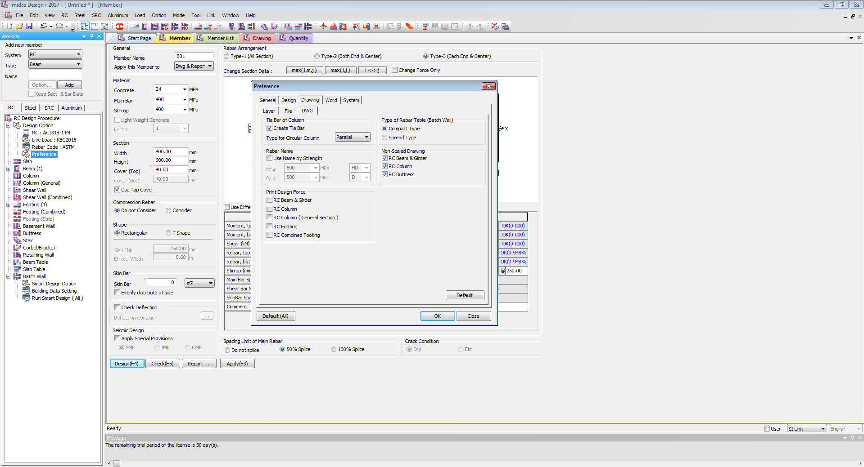









Default setup: In Preferences

**Drawing**

**Layer**

**DWG**

Non Scale Drawing

Check **Yes** RC Beam Drawing

Print Design Force

Check **Yes** RC Beam and Girder

Rebar Option:

Set Default Rebar Option as per Listed in IS 456 2000

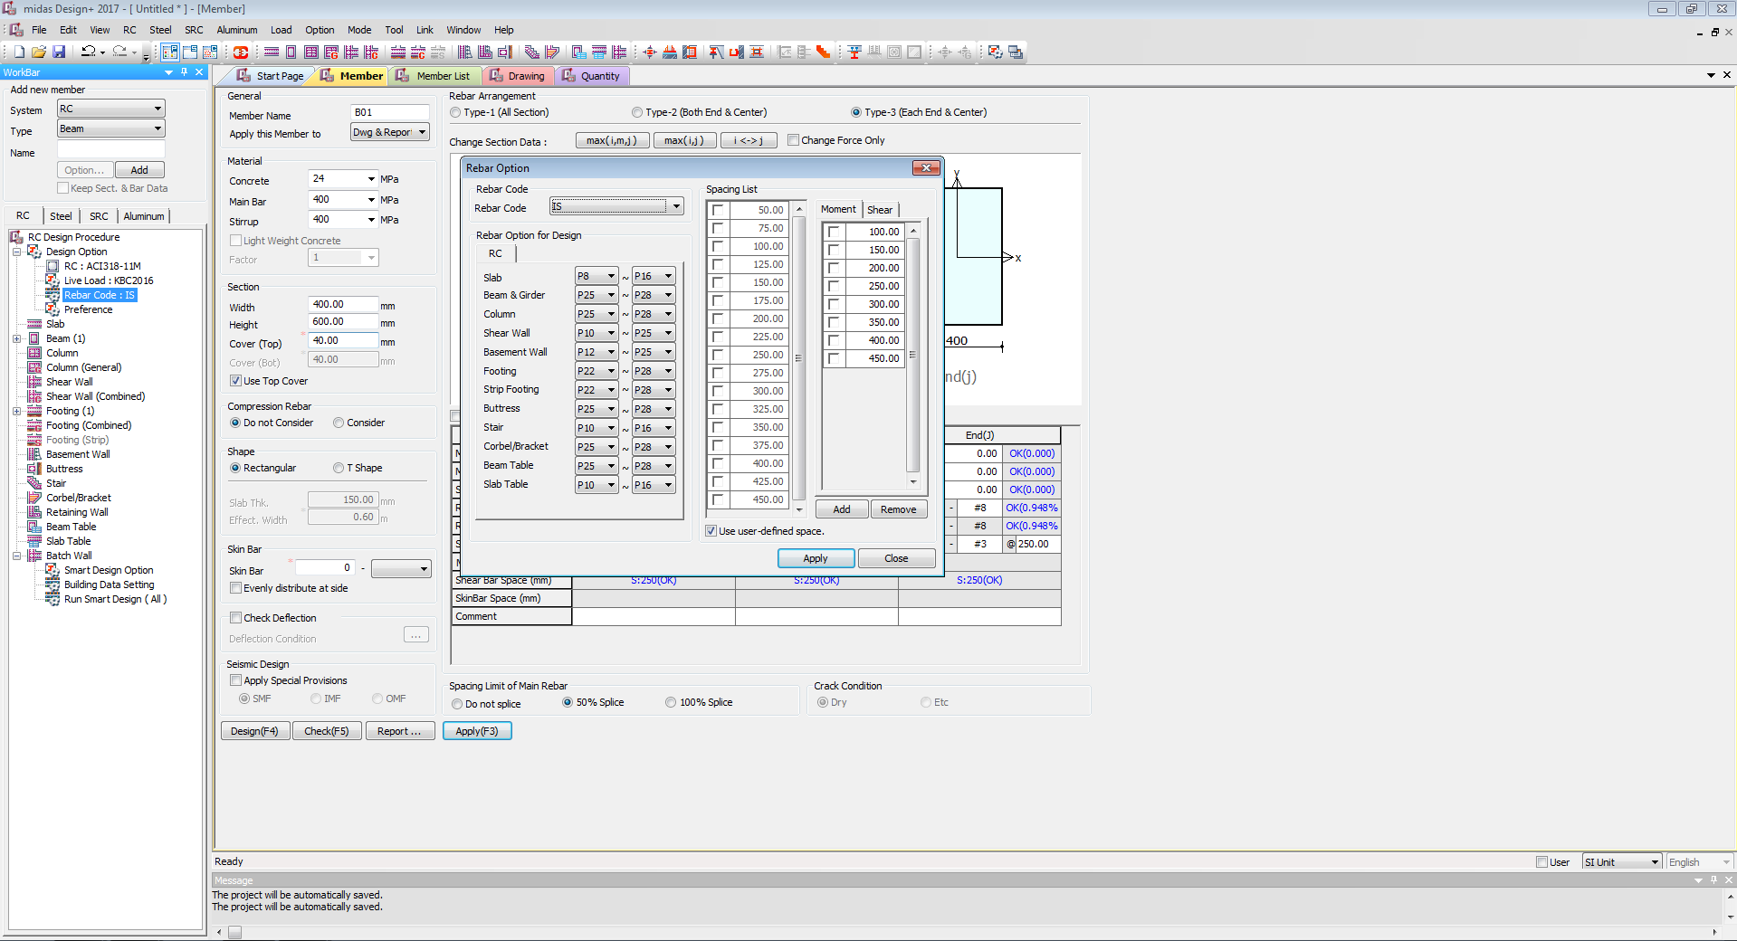









Default setup: In Rebar Code

**Rebar Code**

Rebar Code **IS**

Rebar Option for Design

Beam & Girder **P6 – P28**

Spacing List

Add **50 -100-150-200-250-300-350-450** for Moment and Shear

Set Default Rebar Option as per Listed

**Project Mode:**

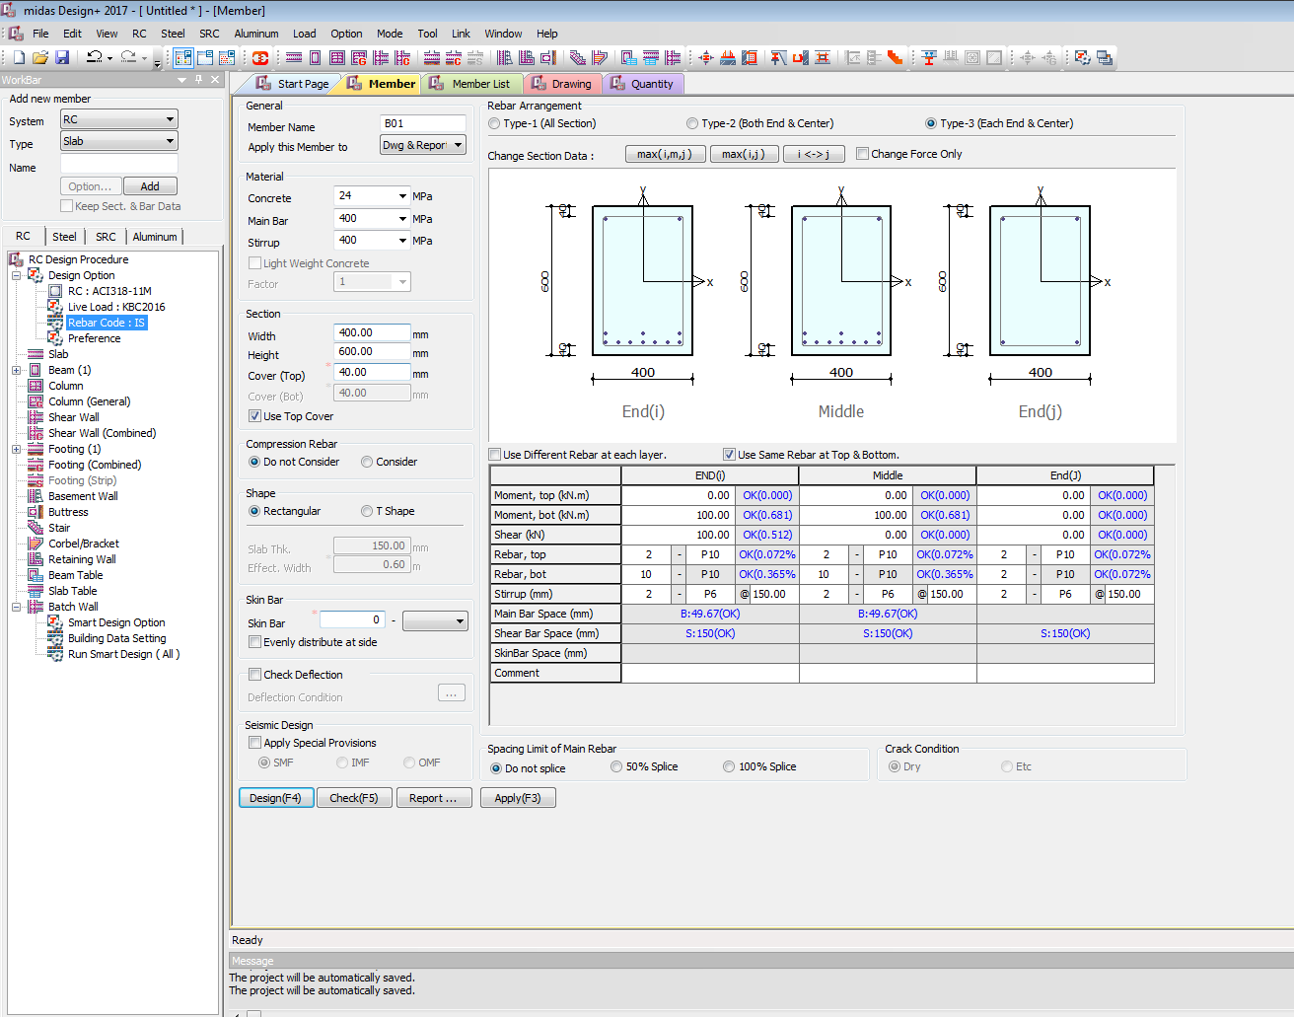











Project Mode: Default are:

General

Rebar Arrangement: **Type-3(Each End & Centre)**

Apply this Member to: **Dwg & Report**

Material

Concrete: **10 15 20 25 30 35 40 45 50 55 60 70 80 90**| Default **25**

Main Bar: **240 415 500 550 600** | Default **415**

Stirrup: **240 415 500 550 600** | Default **415**

Section

Width: **150** **200** **230 250 300 350 400 450…**| Default **230**

**(Show in red if width is below 230) or (If width is below 230 auto update to 230 by pop up window)**

Height: **250 300 350 400 450 500…** | Default **300**

Cover (Top): **40 45 50 55 60** | Default **40**

Cover (Bot): **40 45 50 55 60** | Default **40**

**(Show in red if clear cover is below 40) or (If clear cover is below 40 auto update to 40 by pop up window)**

Check **YES** Use Top Cover

Compression Rebar

Check **YES** do not Consider

Shape

Default Check **YES** Rectangular

If Check YES T**-Shape**

Slab Thickness **120**

Effective Width **600(Calculate as per code book formula)**

Skin Bar **(Considered if Depth is greater than 750 i.e as per code book)**

Default Skin bar **2** – **P6**

Check **YES** evenly distribute at side

**DEFLECTION**

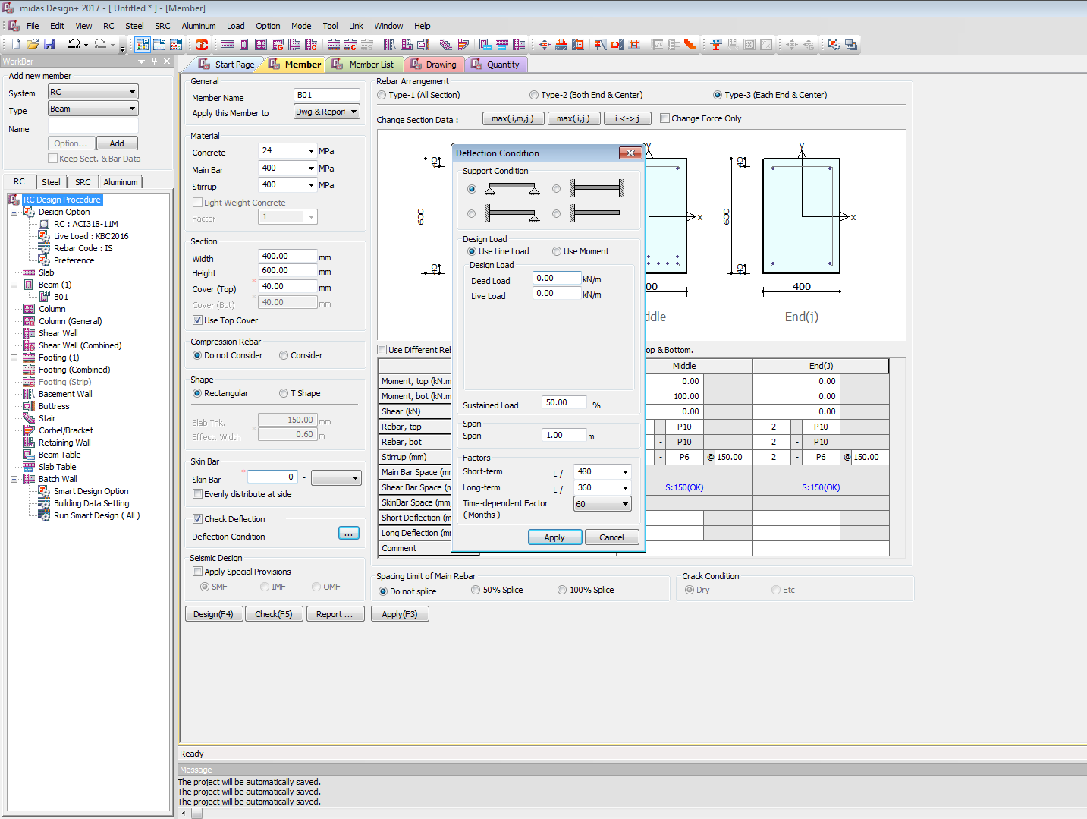

DEFLECTION

Default Check **NO** Deflection Check

If Check **YES** Deflection Check

Activate **Deflection Condition** Menu

Deflection Condition Default to be

Support Condition

**Simply Supported**

Design Load

Default Check **Use Line Load**

Design Load

**Dead Load**

**Live Load**

Sustained Load **50%** (Default)

Span **1** Meter (default)

Factor

Short-Term **L/360**

Short-Term **L/360**

Time Dependent Factor **30** (Default)

Set Default Rebar Option as per Listed



Seismic Design

Check **NO** Default Apply Special Provisions

IF Check **YES** Default Apply Special Provisions (Design as per IS seismic design code book)

Set **SMF** default

Spacing Limit of Main Rebar

**Do Not Splice**

Crack Condition **Dry or Etc (Deactivate)**

Check **NO** default Use Different Rebar at each layer

Check **YES** default Use Different Rebar at each layer

If check **YES** Use different Rebar at each layers

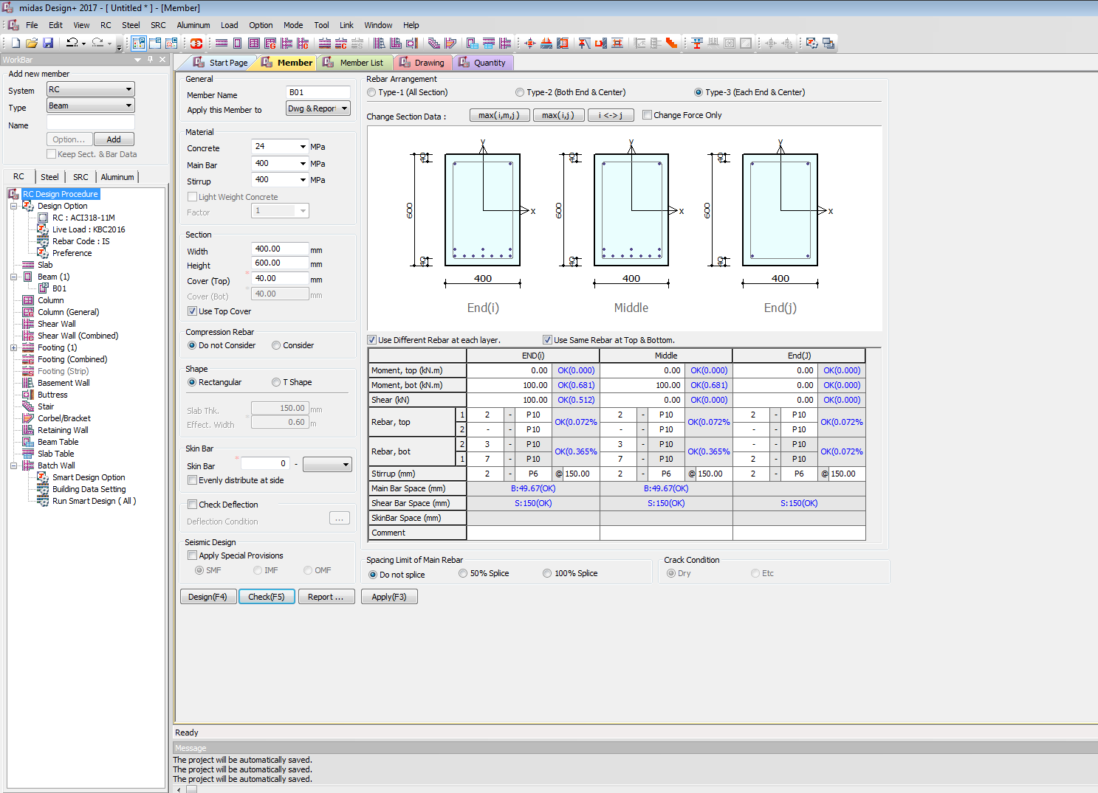

On Check **YES** default Use Different Rebar at each layer

User can input different Rebar details in different **Layers**

Member List

**Project Mode: Member list**

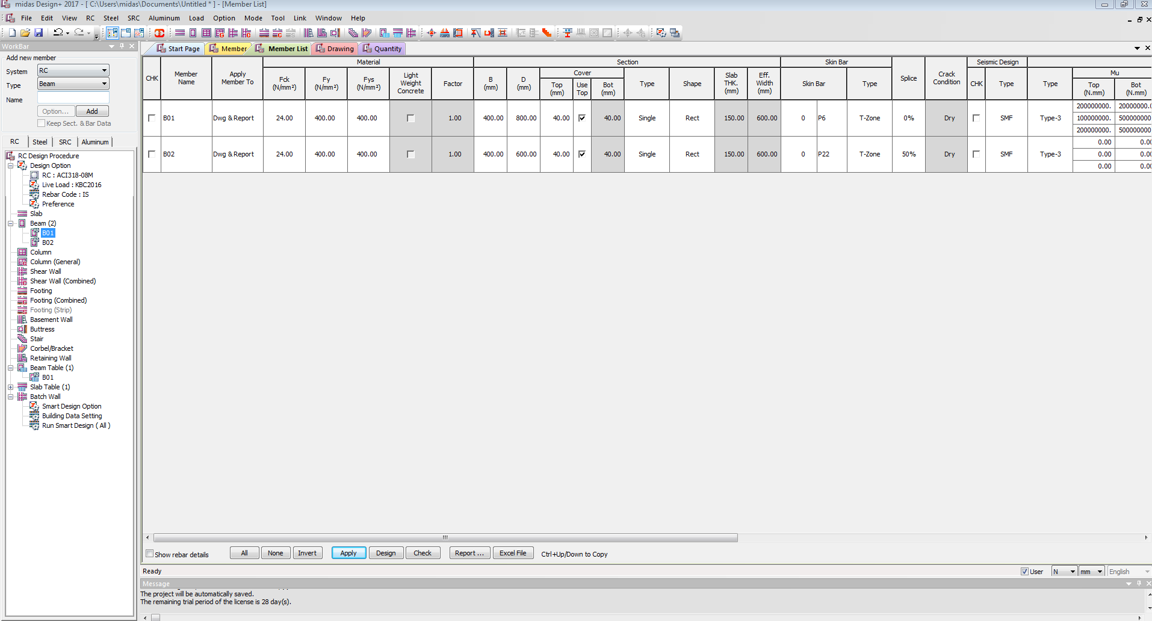



**Project Mode: Member list**

Check **NO** (Default) to Show Rebar Details

Drawing

**Project Mode: Drawing**

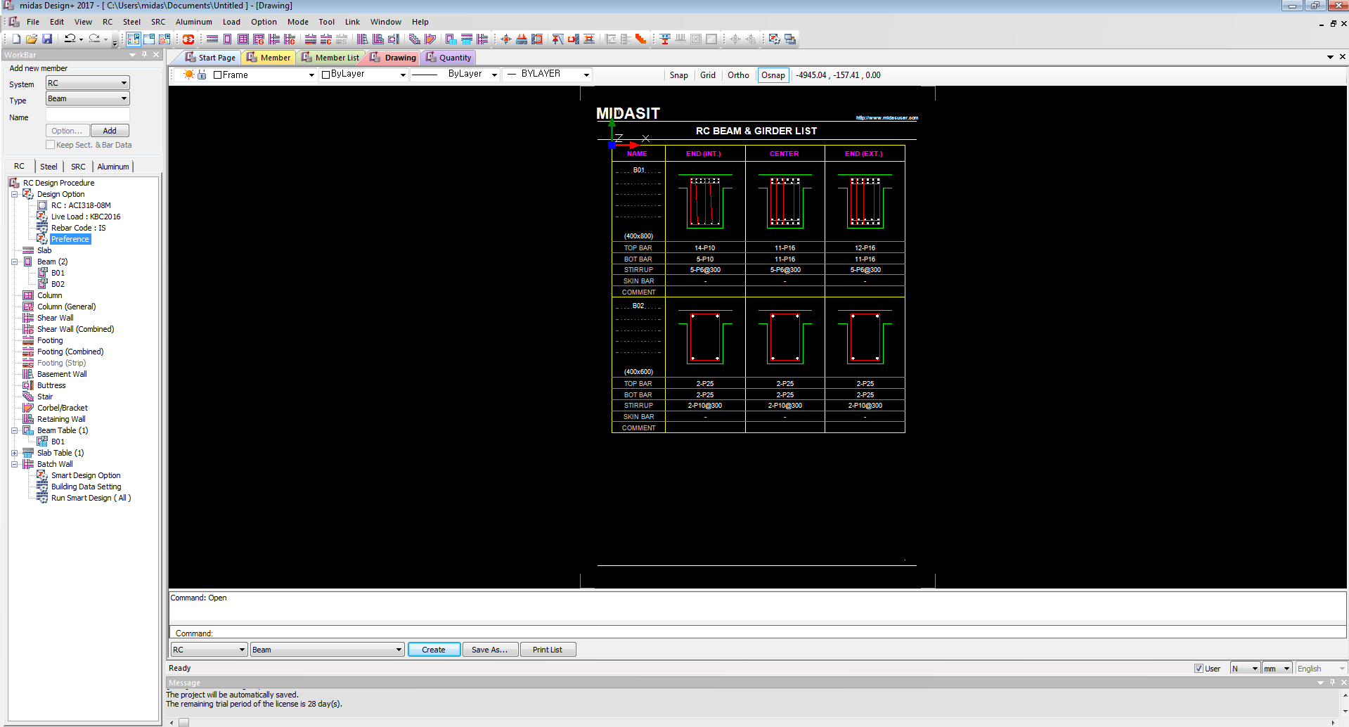

Detail Drawing







**Project Mode: Member list**

**RC BEAM** (Default)

Quantity

**Project Mode: Quantity**

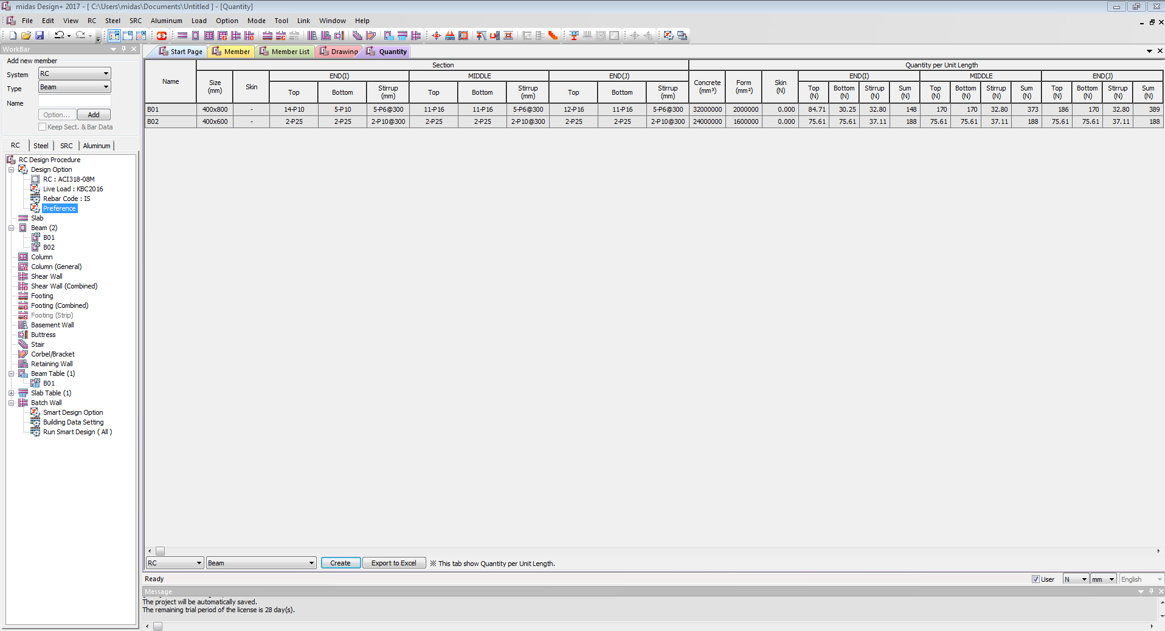





**Project Mode: Quantity**

**RC BEAM** (Default)

**Section Mode:**

SECTION MODE Activation

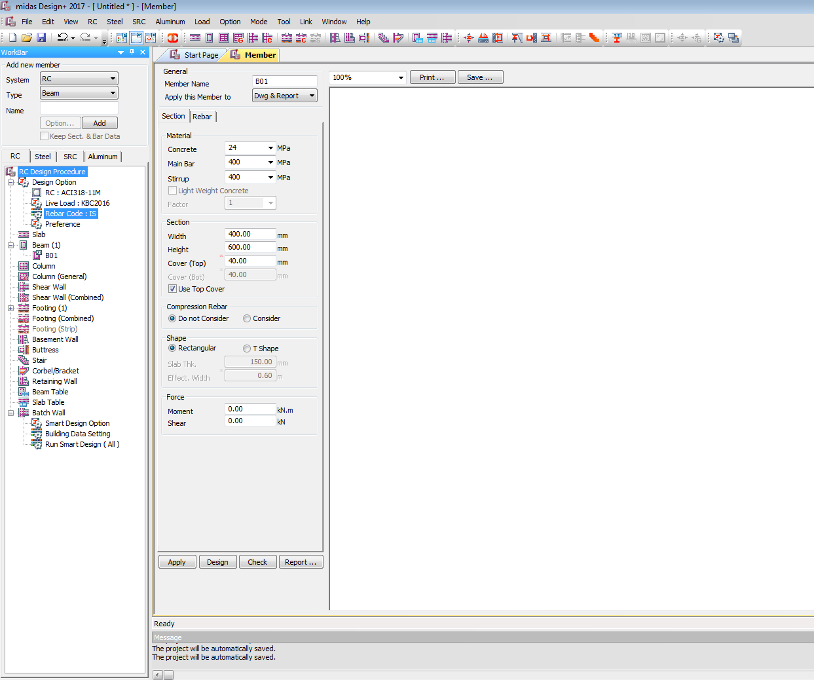

Section Mode: Default are:

General

Apply this Member to: **Dwg & Report**

Material

Concrete: **10 15 20 25 30 35 40 45 50 55 60 70 80 90**| Default **25**

Main Bar: **240 415 500 550 600** | Default **415**

Stirrup: **240 415 500 550 600** | Default **415**

Section

Width: **230 250 300 350 400 450…**| Default **230**

**(Show in red if width is below 230) or (If width is below 230 auto update to 230 by pop up window)**

Height: **250 300 350 400 450 500…** | Default **300**

Cover (Top): **40 45 50 55 60** | Default **40**

Cover (Bot): **40 45 50 55 60** | Default **40**

**(Show in red if clear cover is below 40) or (If clear cover is below 40 auto update to 40 by pop up window)**

Check **YES** Use Top Cover

Compression Rebar

Check **YES** do not Consider

Shape

Default Check **YES** Rectangular

If Check YES T**-Shape**

Slab Thickness **120**

Effective Width **600(Calculate as per code book formula)**

Force

Moment **0** (Default)

Shear **0** (Default)

**Check Mode:**

CHECK MODE Activation

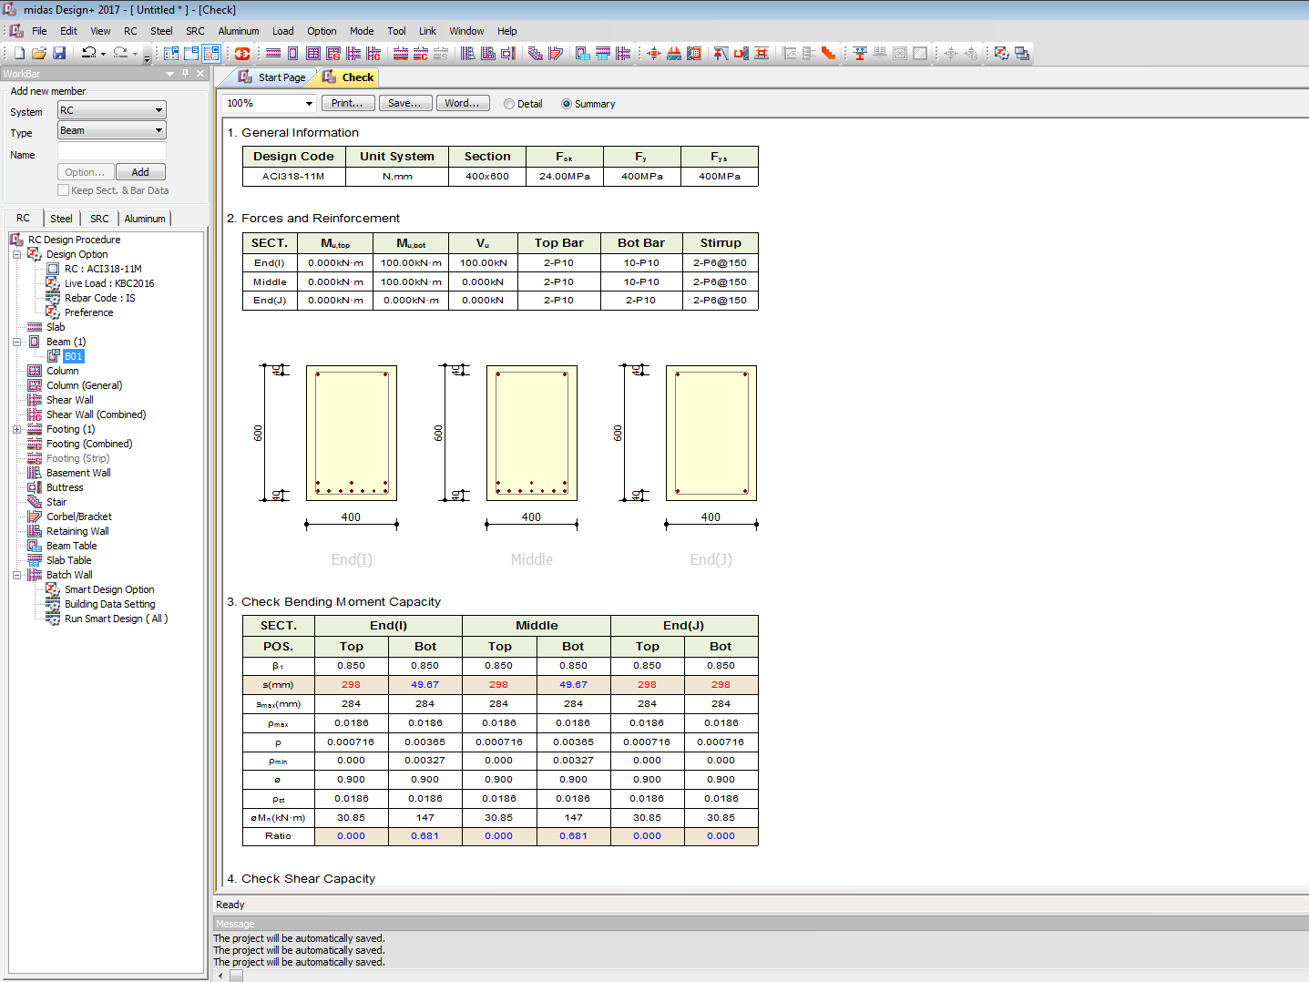

CHECK Mode: Default are:

**SUMMARY report**(Section Mode)

BEAM TABLE

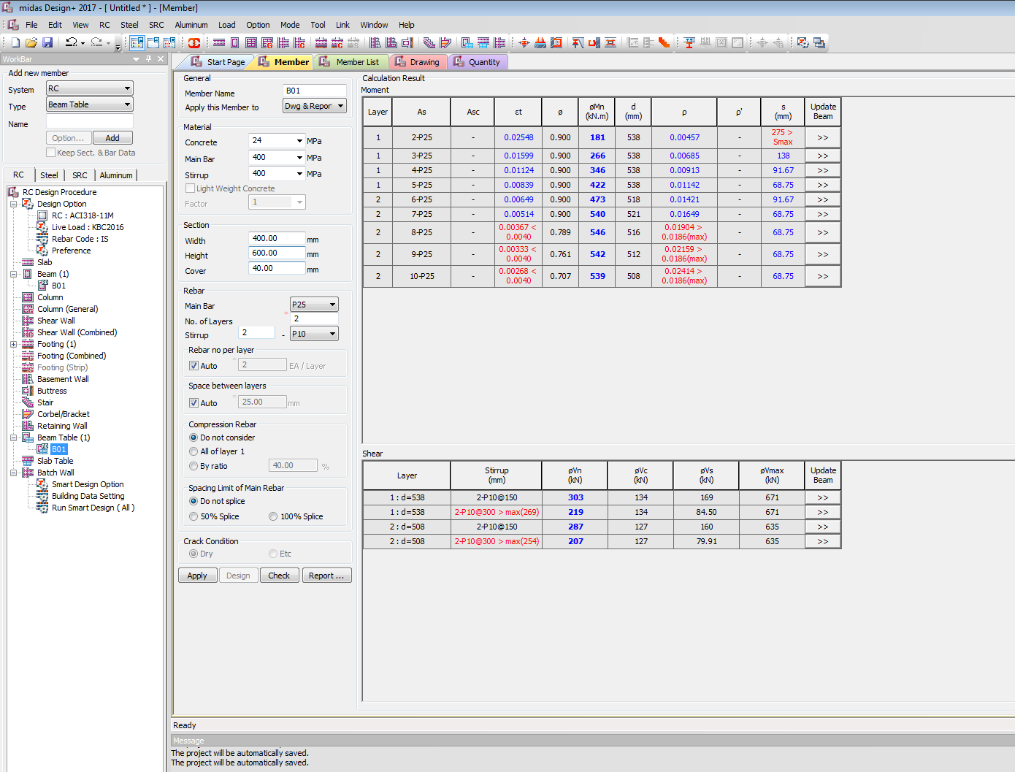

In **Beam Table**:

General

Apply this Member to: **Dwg & Report**

Material

Concrete: **10 15 20 25 30 35 40 45 50 55 60 70 80 90**| Default **25**

Main Bar: **240 415 500 550 600** | Default **415**

Stirrup: **240 415 500 550 600** | Default **415**

Section

Width: **230 250 300 350 400 450…**| Default **230**

**(Show in red if width is below 230) or (If width is below 230 auto update to 230 by pop up window)**

Height: **250 300 350 400 450 500…** | Default **300**

Cover: **40 45 50 55 60** | Default **40**

**(Show in red if clear cover is below 40) or (If clear cover is below 40 auto update to 40 by pop up window)**

Rebar

Main Bar  **P10**  (Default)

No of Layers **2** (Default)

Stirrup **2 – P8** (Default)

Rebar No per Layer

Check **YES** Auto

Spacing Between Layers

Check **YES** Auto

Compression Rebar

Check **YES** do not Consider

Spacing Limit of Main Rebar

Check **Yes** Do not Splice

Crack Condition

Deactivate

BEAM DESIGN OUTPUT

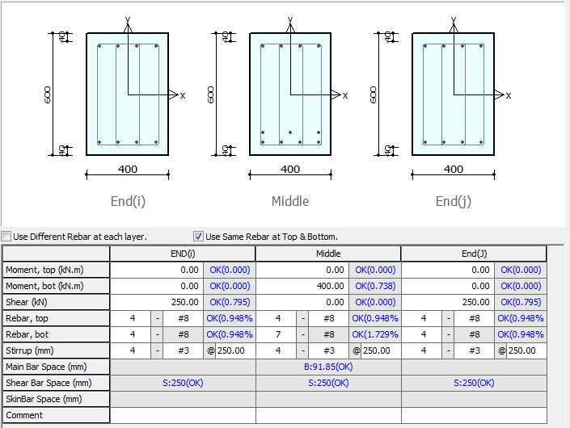

Target ratio = Vinput / Vn

Check Min Max Spacing of Bars

Ratio=Ast /b d (Checks min max)

Target ratio = Minput / Mn

**ALGORITHEMS**

**SINGLE REINFORCEMENT**

*Area of Steel*

**b d Mu fc fy**



**Check Max(take minimum of max)**

**Check Ast min**

Area of Steel

**xu** known

**Balance steel limit Max**

**Number of Bars**

Check

**xu As** unknown

*Area of Steel* Method 2

**b d Mu fc fy**



**Check Max(take minimum of max)**

**Check Ast min**

Area of Steel

**Balance steel limit Max**

**Number of Bars**

Check

**check**

d min from equilibrium

***percentage of Steel limit***

**b d Mu fc fy**

***Xu / d Limit***

**b d Mu fc fy**

***X / d Ratio beam***

**b d Mu**

***X / d Ratio beam***

**b d Ast fc fy**

**ALGORITHEMS**

**DOUBLE REINFORCEMENT**

**b d Mu fc fy**

 *Area of Steel*

d=d-cc-Dia/2

Mu limit

Balance Steel

d’=cc+D/2

**Min Ast min Compression**

**Min Ast min Tensile**

**Balance steel limit Max**

Ast maxTension

Ast max compression

**(take minimum of max)**

**As** = Max of Min and min of max Ast

**Number of Bars As1+**

***Min area of steel Tension***

**b d fy**

***Min area of steel Compression***

**b d**



***Max area of steel Tension***

**b d**

***Max area of steel Compression***

**b d**

***Balance area of steel***

**b d Mu fc fy**

***Resisting Moment of Single Reinforcement Beam Mu Tensile Concrete***

**b d As fc fy Xu**

***Resisting Moment of Single Reinforcement Beam Mu Compression Concrete***

**b d fc Xu**

***Resisting Moment of Doule Reinforcement Beam Mu Compression Concrete***

**b d fc fy xu**

***fsc Compression steel***

**Es d d’ fc Xumax**

***Min Shear reinforcement***

**b d fy**

**Asv**= area of stirrups legs

***Shear Strength of Concrete Tc***

**b d fy fc As**

**Βut not lessthan 1**

***Shear Strength of Concrete Tcmax***

**f**c

**Minimum *Skin Reinforcement Area/Spacing***

**b d**

**d >= 750**

**Steel Must be at tensile part below the neutral axis ?**

***Shear Reinforcement***

**b d As fc fy**



Table 19 20

**Number of Bars**

**d = D-cc- d/2**

**Check Tcmax llimits**

**Asv**= 2 * pi * 10 * 10 / 4 = 157

**Asv**= area of stirrups legs

**N no of legs**

**Sv Spacing**

**Ø Diameter**

**T BEAM**

**Neutral axis is within the flange xu ≤ Df**

**Area of Steel**

**bw d Mu fc fy**



**Check Max(take minimum of max)**

**Check Ast min**

Area of Steel

**xu** known

**Balance steel limit Max**

**Number of Bars**

Check

**xu As** unknown

*Area of Steel* Method 2

**bw d Mu fc fy**



**Check Max(take minimum of max)**

**Check Ast min**

Area of Steel

**Balance steel limit Max**

**Number of Bars**

Check

**check**

d min from equilibrium

x/d from function where b is bw

**T BEAM**

**Neutral axis is within the flange xu > Df &Df/ d ≤ 0.2**

**Area of Steel**

**bw d tf bf Mu fc fy**



**Check Max(take minimum of max)**

**Number of Bars**

**xu As** unknown

**xu** known

Check

CLARIFY THIS OR THIS AS IS BW

Ask

Lhs is rt

Clause 26.5.1.1

Area of Steel

**Check Ast min**

**Balance steel limit Max**

**T BEAM**

**Neutral axis is within the flange xu > Df &Df/ d > 0.2**

**Area of Steel**

**bw d tf bf Mu fc fy**



**Check Max(take minimum of max)**

**Number of Bars**

**xu As** unknown

**Df = Yf**

**Yf = (0.15 xu + 0.65 Df)**

**xu** known

Check

Area of Steel

**Check Ast min**

**Balance steel limit Max**

***Limiting Moment of Beam Single***

**b d As fy xumax fc**

***Limiting Moment of T-Beam***

**xu > Df &Df/ d ≤ 0.2**

**bf Df  bw d As fy xumax fc**

***Limiting Moment of T-Beam***

**xu < Df**

**bf Df  bw d As fy xumax fc**

***Limiting Moment of T-Beam***

**xu > Df &Df/ d > 0.2**

**bf Df  bw d As fy xumax fc**

**Yf = (0.15 xu + 0.65 Df)**

**T-BEAM DOUBLE REINFORCEMENT**

**b d Mu fc fy**

 *Area of Steel*

**Only Moments Calculation changes**

**Remaining calculation same**

**As per case 1 or 2 or 3**

**Mlimits <= Mugiven**

or

d=d-cc-Dia/2

Mu limit

Balance Steel

d’=cc+D/2

**Min Ast min Compression**

**Min Ast min Tensile**

**Balance steel limit Max**

Ast maxTension

Ast max compression

**(take minimum of max)**

**As** = Max of Min and min of max Ast

**Number of Bars As1+**

**Cracking Moment**

**fc**



**Yt = d/2**

**Δ**

**Deflection Limits**

**E DL LL b d fc fy**

***X / d Ratio T- beam***

**bf bw Df Mu**

***.***

***Tensile force beam***

**Ast fy**

**T = 0.87 fy As**

**Steel yield or write in terms of some factor ?**

***Compression force beam***

**b d x fc**

**C = 0.36 fc b x**

***Tensile force T-beam***

**Ast fy**

**T = 0.87 fy As**

**Steel yield or write in terms of some factor ?**

***Compression force T- beam***

**Df bf bw d x fc**

**C = 0.36 fc bw x + 0.45 fc (bf - bw) Df**

***IS 456 BEAM CODE PROVISIONS .***

Long-term deflection  **Span/250**  **[23.2 a]**

Short-term Deflection Factor **Span/350** **[23.2 b ]**

crack moment of section

**[6.2.2]**

**[C-2.1]**

* + - * **+**  **[C-2.1]**

Minimum ratio of reinforcement (flexural)  **[26.5.1.1]**

Check ratio of tensile reinforcement

Calculate Neutral axis  **[ANNEX G]**

Calculate Moment Capacity  **[ANNEX G]**

Concrete Shear Capacity   **[40.4 c] [T table 19]**

Reinforce Shear Capacity

Shear strength by stirrup  **[40.4 c]**

Max area of Compression Reinforcement **0.04 b d**  **[26.5.1.2]**

Max compression + Tensile steel **0.08 b d**

Calculate Moment Capacity compression steel  **[ANNEX G 1-2]**

xu.max the limiting value of xU **xu.max**  **[38.1]**

***Stress in Compression Steel fsc*  [Annex G 1.2]**

Minimum shear reinforcement **[26.5.1.6]**

Design Shear Strength of Concrete ***Tc [Table 19]***

***Shear Strength of Concrete Tc [sp 24 39.2.1]***

*Shear Strength of Concrete Tcmax*  *[Table 20 , sp 16 pno124]*

Design of Shear Reinforcement **[40.4]**

***Xu / d Limit [Table 20 , sp 16 pno124]***

***Effective Width of Flange [*23.1.2*]***

**lo = 0.7 Effective length**

***Beam limiting Moments [Annex G]***

***Beam***  ***[Annex G 1.1]***

**T beam**

***Case 1* xu ≤ Df**

***T-Beam***  ***[Annex G 2.1]***

***Case 2* xu > Df &Df/ d ≤ 0.2**

***T-Beam***  ***[Annex G 2.2.1]***

***Case 3* xu > Df &Df/ d > 0.2**

**Yf = (0.15 xu + 0.65 Df)**

***Use if xu > xumax use xu = max in case 2 and 3 [Annex G 2.3]***

Maximum Allowable Spacing of shear steel **[26.5.1.5]**

**Min of below**

**0.75 d**

**300**

***Minimum Distance between Individual Bars [*26.3.2]**

**Not greater than this :**

**Dia of Large Bar**

**5mm + 20aggregate size**

SPACING OF STIRRUPS IN DOUBLY REINFORCED BEAMS  **[26.5.3.2 c1]**

Min of below 3

**Min (b,d)**

**16 Dia(longitutional)**

**300**

Dia tie must be grater that 0.25 of Dia main bar **[26.5.3.2 c2]**

Check space of skin bar  **[26.5.1.3] d >= 750**

**Area of As>= 0.001 d* bw (0.001)% web Area**

**Steel Must be at tensile part below the neutral axis ?**